FACULTY EVALUATION
Programme Name: Resource Mobilization Programme
Session: Proposal development: Writing winning proposals
Faculty Name: Annette Murunga
No. of Respondents: 9
No. of Participants: 10
Evaluation Parameter | (%) Individual Score | (%) Programme Average
Punctuality | 93 | 96
Clarity of presentation | 93 | 94
Degree of preparation | 96 | 94
Course design & org | 96 | 91
Content & methodology | 98 | 93
Quality of discussions | 96 | 94
Relevance to work | 98 | 95
Average scores | 96 | 94

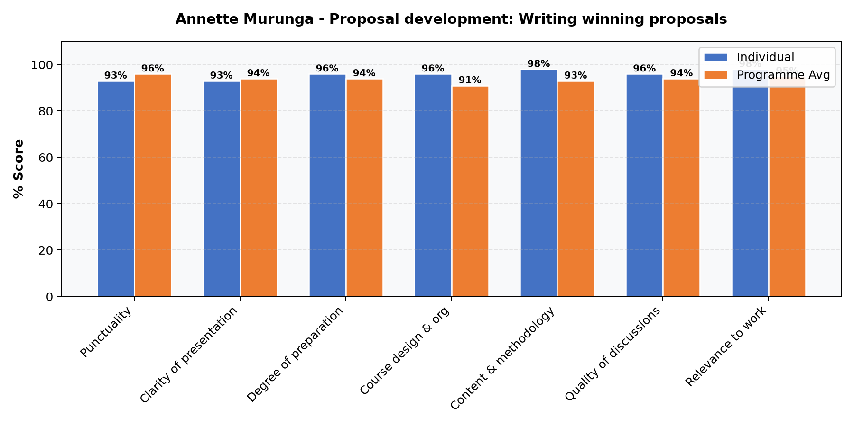

Comments & Feedback
No comments recorded.
SUBMITTED THROUGH:
NAME: ______________________ SIGN: ______________________ DATE: ______________________

